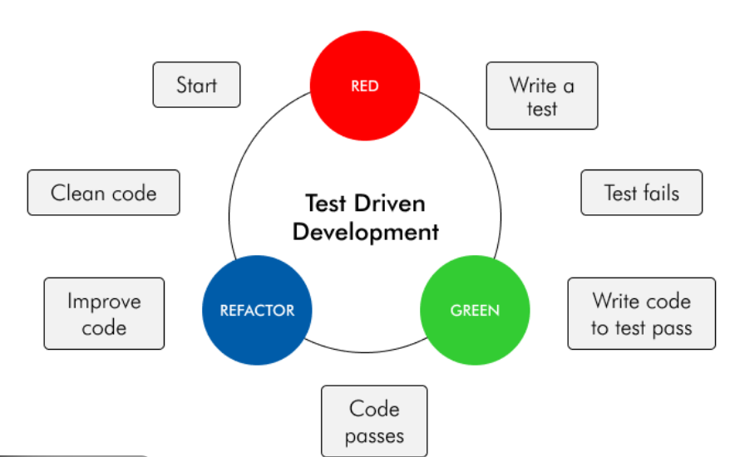

1️⃣ What is TDD (Test Driven Development)?
✅ Definition (Simple Words)
TDD is a software development approach where you write tests before writing actual code.
👉 You think first, code later.

🧠 Traditional Approach vs TDD
Traditional Approach | TDD Approach
Write code | Write test
Test later | Test first
Fix bugs at end | Prevent bugs early
Debugging heavy | Debugging minimal

💡 One-Line Memory Tip
“In TDD, tests drive the design of the code.”

2️⃣ Why TDD? (Why We Use It)
🚨 Problems in Old / Traditional Coding
- Code works today, breaks tomorrow
- Too many bugs found at the end
- Fear of changing existing code
- Hard to maintain large Java projects

✅ Benefits of TDD
✔ Less bugs
✔ Cleaner & modular code
✔ High confidence during changes
✔ Easier refactoring
✔ Better design decisions

3️⃣ What is Red – Green – Refactor Cycle?
This is the heart of TDD ❤️
TDD always follows this 3-step cycle.

🔴 Step 1: RED – Write a Failing Test
What happens?
- You write a test first
- Code is not implemented yet
- Test fails → ❌ (RED)
Why is failure good?
👉 It proves the test is valid and meaningful
Example (JUnit – RED)
@Test
void addTwoNumbers_shouldReturnSum() {
Calculator calc = new Calculator();
assertEquals(10, calc.add(5, 5)); // method not yet implemented
}
📌 Result → Compilation error / Test fails (RED)

🟢 Step 2: GREEN – Write Minimum Code to Pass
What happens?
- Write just enough code
- No optimization
- Make test pass → ✅ (GREEN)
Example (GREEN)
public class Calculator {
public int add(int a, int b) {
return a + b;
}
}
📌 Result → Test passes successfully

🔵 Step 3: REFACTOR – Improve Code Quality
What happens?
- Clean code
- Remove duplication
- Improve naming
- Optimize logic
- Tests should still pass
Example (REFACTOR)
public class Calculator {
public int add(int first, int second) {
return first + second;
}
}
✔ No behavior change
✔ Better readability

🔁 The Cycle Repeats
RED → GREEN → REFACTOR → RED → GREEN → REFACTOR
🧠 Memory Trick
Fail fast → Fix fast → Clean fast

4️⃣ Why It Is Called Red – Green – Refactor?
Color | Meaning | Why
🔴 Red | Test fails | IDE shows red
🟢 Green | Test passes | IDE shows green
🔵 Refactor | Improve code | Maintain quality
👉 Names come directly from JUnit / IDE test indicators

5️⃣ Where Do We Use TDD?
✅ Best Use Cases
Area | Example
Business logic | Salary calculation
Financial apps | Tax, EMI, Interest
APIs | Service layer testing
Microservices | Unit tests for services
Utilities | Validators, parsers

❌ Where TDD is NOT Ideal
- UI heavy code (HTML/CSS)
- Quick prototypes
- One-time scripts

6️⃣ Real-World Java Example (Employee Salary)
🔴 RED – Test First
@Test
void calculateSalary_withBonus() {
EmployeeService service = new EmployeeService();
assertEquals(55000, service.calculateSalary(50000, true));
}

🟢 GREEN – Minimal Code
public int calculateSalary(int base, boolean bonus) {
return bonus ? base + 5000 : base;
}

🔵 REFACTOR – Clean Code
public int calculateSalary(int baseSalary, boolean hasBonus) {
return hasBonus ? baseSalary + BONUS_AMOUNT : baseSalary;
}

7️⃣ Why Trainers Love TDD ❤️
- Forces thinking before coding
- Perfect for JUnit teaching
- Explains why testing matters
- Makes students confident

TDD is a development practice where tests are written before code. It follows the Red-Green-Refactor cycle, ensuring code correctness, better design, and early bug detection.

9️⃣ Final Memory Hook 🧠✨
❝ If your code is not testable, it is not maintainable ❞

